**File Manager**

**Introduction**

# Project 1: File Manager University Name: <http://www.sjsu.edu/> Course: [Cloud Technologies](http://info.sjsu.edu/web-dbgen/catalog/courses/CMPE281.html) Professor: [Sanjay Garje](https://www.linkedin.com/in/sanjaygarje/) ISA: Anushri Srinath Aithal

Student: Sudha Amarnath

**File Manager Introduction – Project Idea**

File manager is a 3-tier web application hosted on AWS cloud, where in authorized users can manage and maintain their files. Various AWS components leveraged in this project provides a highly scalable, highly available and cost effective solution for backing up data in S3 bucket, which is accessible over a public internet through registered domain name via Route 53. Auto-scaling group is used to spin up a new EC2 instance during peak workloads and terminate the same when not needed. Health of the EC2 instance associated with autoscaling group is monitored through AWS cloudwatch, SNS and Lambda. The web application code can be developed, built and deployed through CodeStar and EC2 instance profile is created for code deploy application and deployment group and to create code pipeline.

Operations performed by users in this web app:

* Upload files to s3 bucket
* Download files via s3 from cloudfront distribution
* Delete files from S3
* Edit already uploaded files

Operations performed by Admin in this web app:

* List users
* Browse user files uploaded on s3
* Modify user uploaded files
* AWS architecture for this project

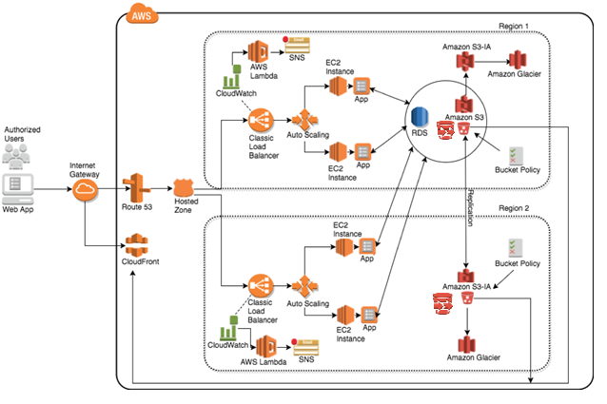

* Continuous deployment flow

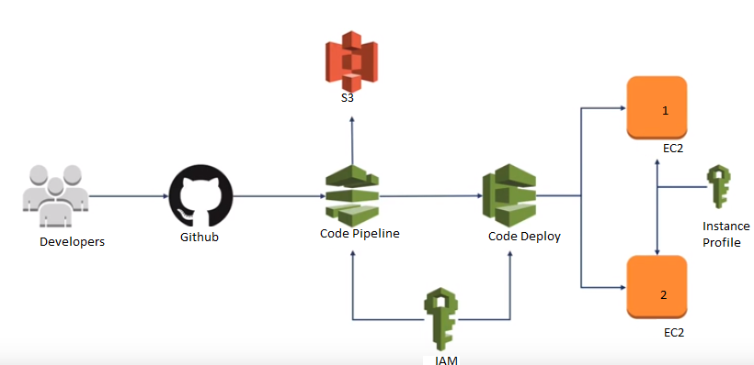

**Feature list**

* New user form for unregistered users to create an account. A database record is created for each new user in AWS RDS MySQL.
* Login page for authorized users to login.
* Landing page after login that has user first name and last name displayed. Multiple file upload widget. List of all the files previously uploaded files. Download, delete and edit files options for the uploaded files. RDS shows up all the user details, updated time and date .
* The upload file doesn’t allow files to be uploaded exceeding 10MB.
* Authorized users can download files from the already uploaded files and modify and update the changes.
* User can Logout using the logout button.
* Admin can login the website and has access to see user list and browse through all the uploaded users and modify(delete) their files and successfully logout of the website.

**Solution for each requirement present in the problem statement**

* Create an amazon AWS account and sign into the console.
* Create two S3 buckets with cross regions replication with transfer acceleration with lifecycle policy (S3->S3IA->Glacier) 75 days -> 1year -> 1year and delete after that policy is enabled.
* Link your S3 bucket with Cloudfront with TTL 1 minute, to offload traffic from the origin.
* This application is deployed in Elastic Beanstalk environment, where it creates an environment by triggering EC2 instance, Auto Scaling group to maintain availability during outage, Elastic load balancing to make sure load on instances are distributed and MYSQL RDS instance with MYSQL workbench.
* Cloud watch alarms are set to check for healthy state of EC2 instances.
* Lambda Function trigger to receive cloud watch alerts for an unhealthy state and send out notification to the user regarding the event through email as endpoint.
* Create a Route53 domain name server that resolves IP address for the created application domain.
* Deploy application code via AWS codestar and set up EC2 instance profiles into deployment groups DEV, STAG, PROD agents to with ELB using CodeDeploy.

**Technologies used**

* Spring 4.0.6.RELEASE
* Apache Tomcat/9.0.12
* Hibernate Core 4.3.6.Final
* MySQL Server 5.6
* JSP and CSS
* Maven 3
* JDK 1.6
* Eclipse JUNO Service Release 2

**Sample Screen Shots**

Login page

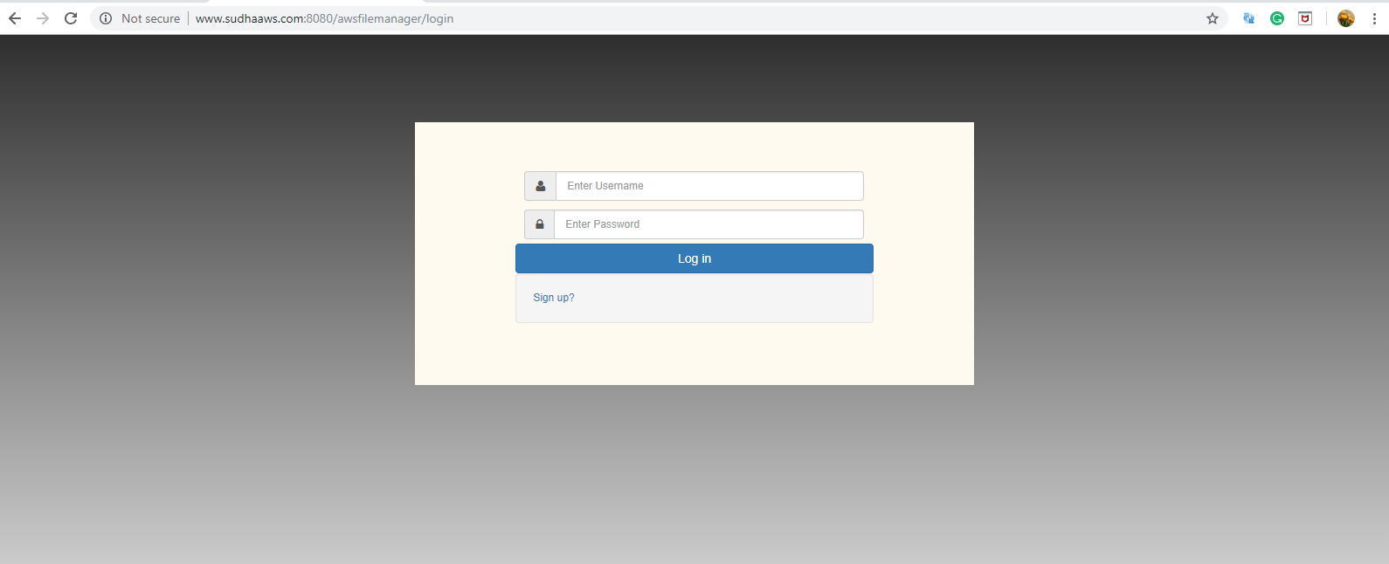

Admin Panel – Initial user list

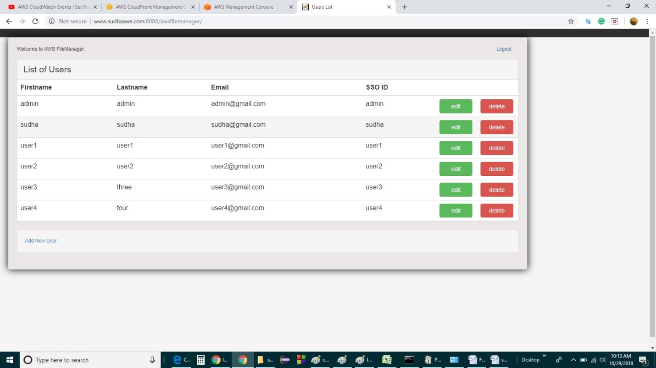

User Registration

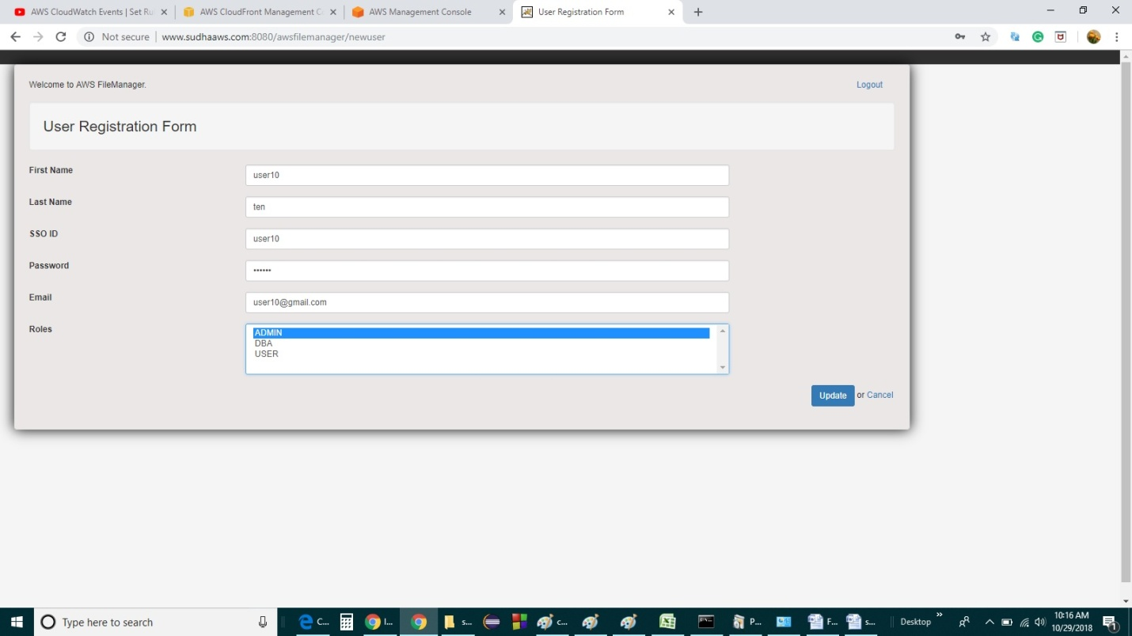

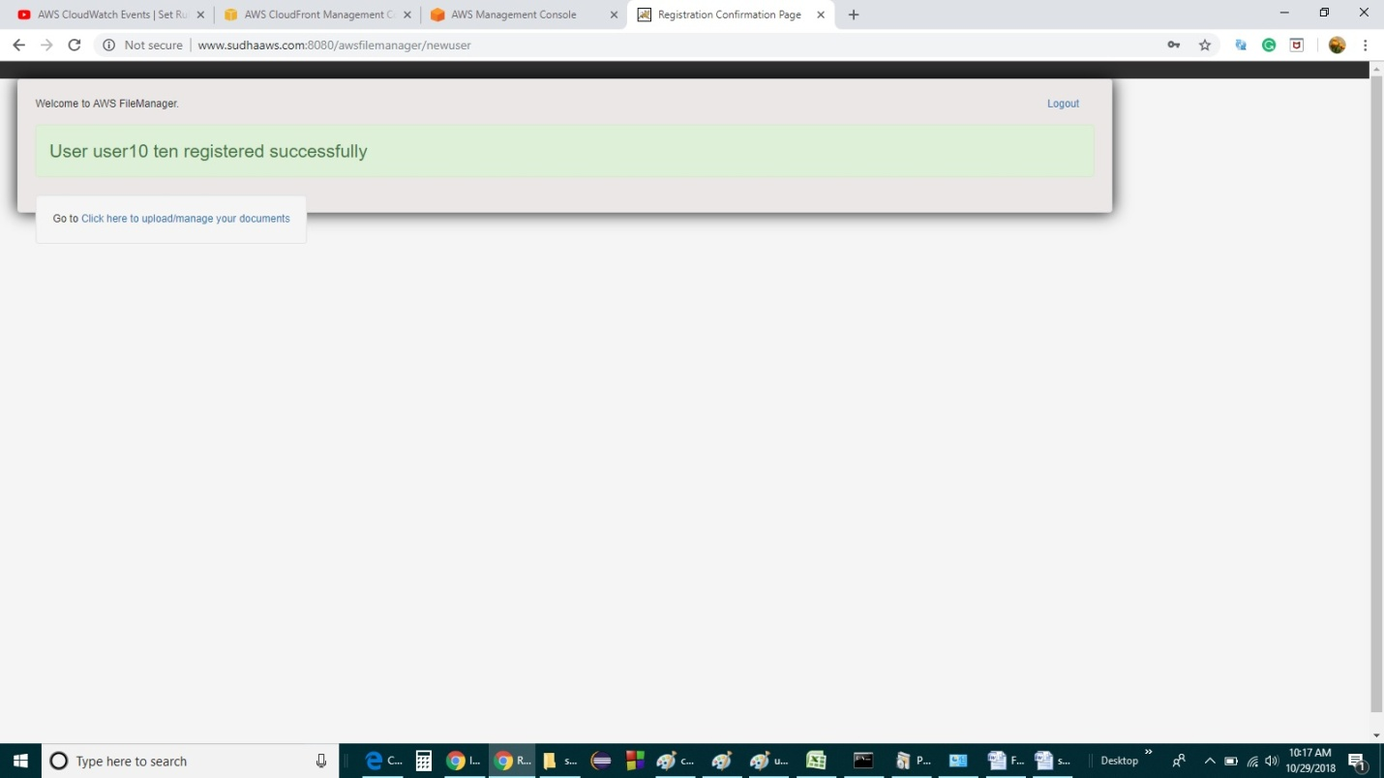

Uploading files

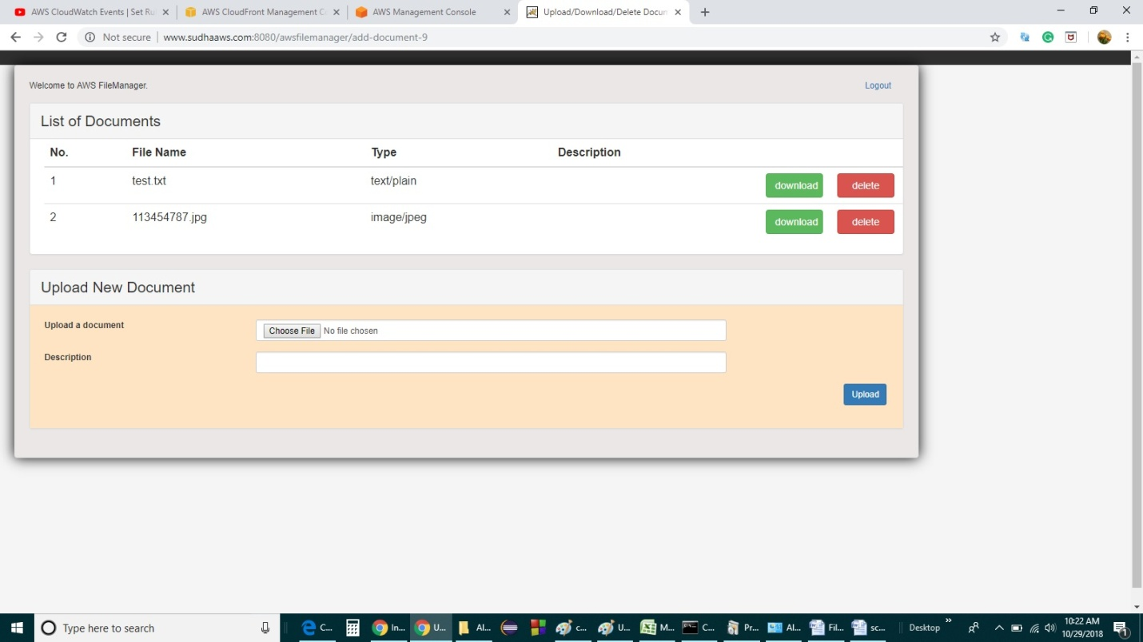

User details and file uploaded time in MySQL workbench

